**THREEE-THE NEW DEFINITION OF ENTERTAINMENT**

**A MINI PROJECT REPORT**

Submitted in partial fulfilment of the Requirement

for the award of the degree of

**Bachelor of Engineering**

in

**Information Technology**

By

M.Pavansrivatsa

(1608-19-737-001)

Srivarsha.K

(1608-19-737-005)

Ch.Yaswanth Sai

(1608-19-737-009)

Under the guidance of

Ms. S.T.S.A.V Ramya

Assistant Professor



**Department of Information Technology**

**mATRUSRI ENGINEERING COLLEGE**

**JUNE, 2022**

**mATRUSRI ENGINEERING COLLEGE**

**SAIDABAD - 500059**



**Department of Information Technology**

Certificate

This is to certify that the project report entitled **“THREEE”** submitted by **M. Pavansrivatsa** bearing **H.T. No: 1608-19-737-001, Srivarsha.K** bearing **H.T. No: 1608-19-737-005, Ch.Yaswanth Sai** bearing **H.T. No: 1608-19-737-009,** in the partial fulfilment of the requirement for the award of the degree of **Bachelor of Engineering** in **Information Technology** is a bonafide work carried by him/her**.**

The results of the investigations enclosed in this report have been verified and found satisfactory.

Ms. S.T.S.A.V Ramya Dr. G. Shyama Chandra Prasad

Assistant Professor **HOD**

**mATRUSRI ENGINEERING COLLEGE**

**SAIDABAD - 500059**



**Department of Information Technology**

dECLARATION BY THE CANDIDATE

we, **M.Pavansrivatsa** bearing **H.T. No: 1608-19-737-001, Srivarsha.k** bearing **H.T. No: 1608-19-737-005, Ch.Yaswanth Sai** bearing **H.T. No: 1608-19-737-009, hereby** certify that the mini project report entitled **“THREEE”** is submitted in the partial fulfilment of the requirement for the award of the degree of **Bachelor of Engineering** in **Information Technology.**

This is a Record of bonafide work carried out by us under the guidance of **S.T.S.A.V** **Ramya**,Assistant Professor,Matrusri Engineering College,Saidabad. The results embodied in this report have not been reproduced/copied from any source. The results embodied in this report have not been submitted to any other university or institute for the award of any other degree or diploma.

(signature)

**M.Pavansrivatsa (1608-19-737-001)**

**Srivarsha.K (1608-19-737-005)**

**Ch.Yaswanth Sai (1608-19-737-009)**

**ACKNOWLEDGEMENT**

We wish to take this opportunity to express our deep gratitude to all the people who have extended their cooperation in various ways during our mini project work. It’s our pleasure to acknowledge the help of all those individuals.

Firstly, we would like to thank **Dr. G. Shyama Chandra Prasad (HOD, IT DEPT)** for his encouragement and valuable guidance in bringing shape to dissertation.

We would like to thank our project guide, **S.T.S.A.V Ramya** **(Assistant Professor, IT DEPT)** and for her guidance and help throughout the development of this project work by providing us with required information and support. Without her guidance, cooperation and encouragement, we couldn’t learn many new things during our mini project tenure.

**M.Pavansrivatsa (1608-19-737-001)**

**Srivarsha.K (1608-19-737-005)**

**Ch.Yaswanth Sai (1608-19-737-009)**

**ABSTRACT**

* Our V movie clone present the various OTT services, audience characteristics, content, and future developments expected in the industry.
* Our V tunes software is the secret to joining the lucrative audio listening market and obtaining an edge. A robust portal to produce millions of songs of all genres is a treat.
* Games are stress busters used to entertain people. V Games provide multiple games which are easy to understand and play without any complicated structures. There is no age limit, everyone can play in our website, our website have simple games to have fun.

**Technology stack:**

* Visual studio code-For Developing Application.
* HTML, CSS & JS -For Frontend Development.
* MongoDB & NodeJs -For Backend Development.

**Advantages of Our Project:**

* This model is user-friendly.
* People of all ages can use the website.
* It provides multiple features to the user at the same place,

it saves the time of the user.

**CONTENTS**

**S.No Chapter Page No**

**1. INTRODUCTION 1-2**

1.1 Objective 1

1.2 Existing System 2

1.3 Proposed System 2

**2. METHODOLOGY 3-4**

2.1 Methodology 3

2.2 Working 4

**3. UML DIAGRAMS 4-7**

3.1 Use case diagram 4

3.2 Activity diagrams 5

3.3 State Chart Diagram 5-7

**4. SOURCE CODE 8-19**

**5. OUTPUT 20-22**

**6. CONCLUSION 23**

**7. FUTURE ENHANCEMENTS 23**

**8. REFERENCE 23**

**List of Figures**

**Figure Title Page No**

**3**. **UML DIAGRAM 5-7**

3.1 Use Case Diagram 5

3.2 Activity Diagram 6

3.3 State Chart Diagram 7

**5. OUTPUT 20-22**

5.1 Registration 20

5.2 Login 20

5.3 Home Page 21

5.4 V-MOVIEEE 21

5.5 V-GAMEEE 22

5.6 V-TUNEEE 22

**1. INTRODUCTION**

* OTT video platforms, once considered a luxury is today a commodity. In India, there is an increasingly growing number of consumers adapting to it. **THREEE** is a user interface and user-friendly website.
* Generally, the basic source of entertainment is through watching movies, to listening music and playing games. This has become more prominent during this covid pandemic.
* A registered user can directly enter the website by logging into his account using username and password. Users can choose an options among these three categories. Users can watch a movie or play a game or listen to music based on his/her interest.

**1.1 Objective**

* To establish an interface for the user to watch movies.
* To establish an interface for the user to listen to music.
* To establish an interface for the user to play games.
* To provide safe and secure user accounts.

**1.2 Existing System**

* Generally the existing website only provide the user with limited access and the user must pay huge amount.
* There are multiple websites for playing games, movie streaming and for listening music.
* The user needs lot of time.
* These doesn’t meet all the user requirements.

**1.3 Proposed System**

* The aim of proposed system is to develop a application of improved features such as
* User-friendly and Interactive.
* Highly secure.
* Greater Efficiency.
* Better Service.
* THREEE provides the user to perform tasks like watching movies, listening to music and playing games on the same page.
* People of all ages can use the website.
* As it provides multiple features to the user at the same place,

it saves the time of the user.

**2. METHODOLOGY OF THE PROJECT**

**2.1 METHODOLOGY:**

Our project is developed using HTML CSS & JS.And backend is devloped using mongoDB & NodeJS.

**2.1.1 What is HTML?**

* The HyperText Markup Language or HTML is the standard markup

language for documents designed to be displayed in a web browser.

* Web browsers receive HTML documents from a web server or from local

storage and render the documents into multimedia web pages.

* HTML describes the structure of a web page symantically and originally

included cues for the appearance of the document.

**2.1.2 What is CSS?**

* Cascading Style Sheets (CSS) is a style sheet language used for describing the presentation of a document.
* CSS is designed to enable the separation of presentation and content, including layout, colors, and fonts.

**2.1.3 What is JS?**

* JS is abbreviated as java-script, it is one of the core technologies of the World Wide Web.
* JavaScript engines were originally used only in web browsers, but are now core components of some servers and a variety of applications. The most popular runtime system for this usage is NodeJS.

**2.1.4 What is MongoDB?**

* MongoDB is an open source cross-platform document-oriented database program. Classified as a NoSQL database program, MongoDB uses JSON-like documents with optional schemas.
* MongoDB is developed by MongoDB Inc[.](https://en.wikipedia.org/wiki/MongoDB_Inc.) and licensed under the SSPL which is deemed non-free by several distributions.

**2.1.5 What is NodeJS?**

* NodeJS is an open-source, cross-platform, back-end JavaScript runtime environment that runs on the V8 engine and executes JavaScript code outside a web browser, which was designed to build scalable network applications.
* NodeJS has an event-drive architecture capable of asynchronous I/O. These design choices aim to optimize throughput and scalability in web applications with many input/output operations, as well as for real-time web applications

**2.2 WORKING:**

This website work on the users choice. He/she can choose any of the provided options. The user is directed to the page chooses and can have access to the provided options. The first mandatory step is to login or register. Later the user will have the ability to use the website without a large, one-time cost upfront. The working of the website is explained by the UML diagrams.

**3. UML DIAGRAMS**

The Unified Modelling Language (UML) is a standard language for writing software blue prints. The UML is a language for:

* Visualizing
* Specifying
* Constructing
* Documenting the artifacts of a software intensive system.

The UML is a language which provides vocabulary and the rules for combining words in that vocabulary for the purpose of communication. A modelling language is a language whose vocabulary and the rules focus on the conceptual and physical representation of a system. Modelling yields an understanding of a system.

There are two broad categories of diagrams and they are again divided into structural diagrams and behavioural diagrams. The structural diagrams represent the static aspect of the system. The four structural diagrams are class diagram, object diagram, component diagram, and deployment diagram. Behavioural diagrams basically capture the dynamic aspect of a system. Types of behavioural diagrams are use case diagram, sequence diagram, collaboration diagram, state chart diagram, activity diagram. Some of the frequently used use case diagrams in software development are:

* Use Case diagrams
* Activity diagrams
* State Chart diagrams

**3.1 Use case Diagram**

Use-Case Diagram is used to gather the requirements of a system including internal and external influences. These requirements are mostly design requirements. In brief, purpose of Use- Case is:

* Gathering Requirements of System
* To get outside View of a system
* Identify the internal and external factors influencing system.
* Show the relation between Requirements and Actors.

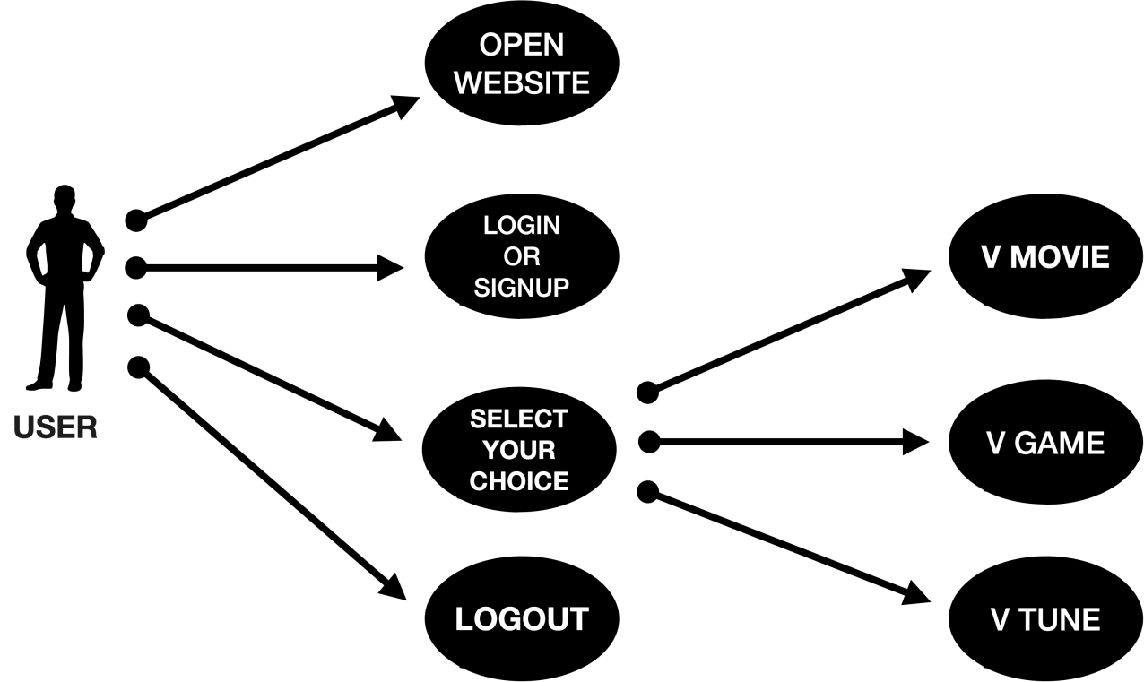

**Figure 3.1 Use Case Diagram**

**3.2 Activity Diagram**

An activity diagram is a special case of state diagram. An activity diagram is like a flow Machine showing the flow a control from one activity to another. An activity diagram is used to model dynamic aspects of the system Activities are nothing but the functions of a system. Numbers of activity diagrams are prepared to capture the entire flow in a system

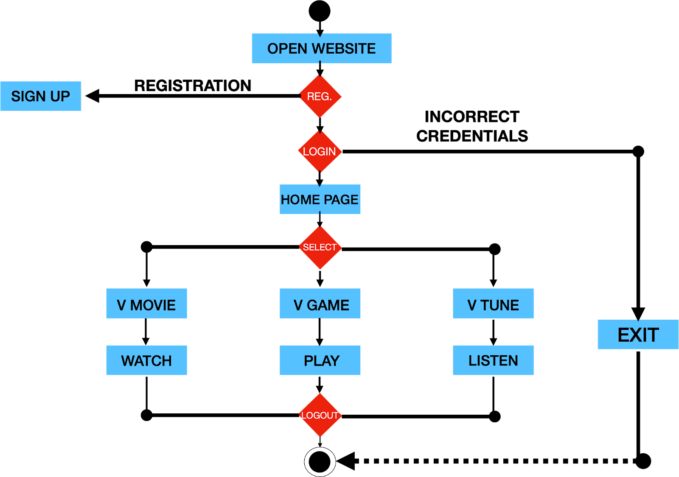

**Figure 3.2 Activity Diagram for Application**

**3.3 State Chart Diagram**

State chart diagram is used to describe the states of different objects in its life cycle. Emphasis is placed on the state changes upon some internal or external events. These states of objects are important to analyse and implement them accurately.

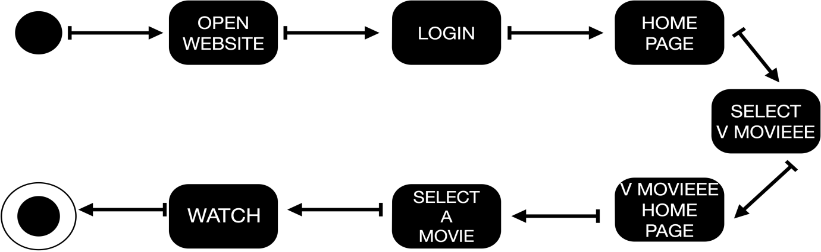

**Figure 3.3.1 State Diagram of V MOVIEEE**

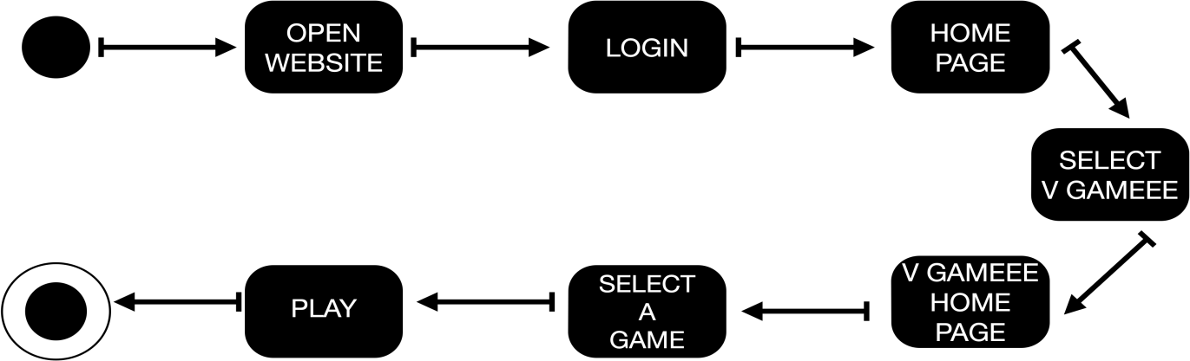

**Figure 3.3.2 State Diagram of V GAMEEE**

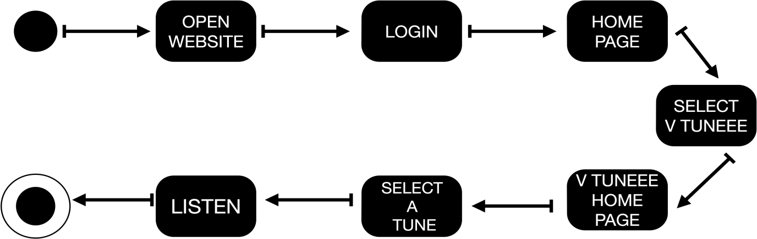

**Figure 3.3.3 State Diagram of V TUNEEE**

**4. SOURCE CODE**

* **V-Movie:**

<!DOCTYPE html>

<html lang="en">

<head>

<meta charset="UTF-8" />

<meta name="viewport" content="width=device-width, initial-scale=1.0" />

<link rel="stylesheet" href="style.css" />

<title>V-MOVIEEE</title>

<link rel="icon" href="../ic_launcher.png" />

</head>

<body>

<header>

<div class="heading">

<h1>V-MOVIEEE</h1>

</div>

<div class="icon">

<ul>

<li><a href="../V-Movieee/index.html">V-Movieee</a></li>

<li><a href="../V-Gameee/gameee.html">V-Gameee</a></li>

<li><a href="../V-Tuneee/tune.html">V-Tuneee</a></li>

<li><a href="../login.html">Logout</a></li>

</ul>

<form id="form">

<input type="text" placeholder="Search" id="search" class="search" /></form></div>

</header>

<div id="tags"></div>

<div id="myNav" class="overlay">

<a href="javascript:void(0)" class="closebtn" onclick="closeNav()"

>&times;</a

>

<div class="overlay-content" id="overlay-content"></div>

<a href="javascript:void(0)" class="arrow left-arrow" id="left-arrow"

>&#8656;</a

>

<a href="javascript:void(0)" class="arrow right-arrow" id="right-arrow"

>&#8658;</a

>

</div>

<main id="main"></main>

<div class="pagination">

<div class="page" id="prev">Previous Page</div>

<div class="current" id="current">1</div>

<div class="page" id="next">Next Page</div>

</div>

<script src="script.js"></script>

</body>

</html>

* **V-Game:**

<!DOCTYPE html>

<html lang="en">

<head>

<meta charset="UTF-8" />

<meta http-equiv="X-UA-Compatible" content="IE=edge" />

<meta name="viewport" content="width=device-width, initial-scale=1.0" />

<title>V-GAMEEE</title>

<link rel="stylesheet" href="./css/gameee.css" />

<link rel="icon" href="./Images/ic_launcher.png" />

<style>

@import url("https://fonts.googleapis.com/css2?family=Libre+Baskerville&display=swap");

</style>

</head>

<div class="main">

<div class="heading">

<h1>V-GAMEEE</h1>

</div>

<div class="icon">

<ul>

<li><a href="../V-Movieee/index.html">V-Movieee</a></li>

<li><a href="../V-Gameee/gameee.html">V-Gameee</a></li>

<li><a href="../V-Tuneee/tune.html">V-Tuneee</a></li>

<li><a href="../login.html">Logout</a></li>

</ul>

</div>

</div>

<body class="all">

<div class="flexbox">

<div class="card">

<img

src="https://upload.wikimedia.org/wikipedia/commons/thumb/8/89/Wild_tic-tac-toe.svg/220px-Wild_tic-tac-toe.svg.png"

class="card-img"

alt=""

/>

<p class="text">

Tic Tac Toe is a two-player game in which the objective is to take

turns and mark the correct spaces in a 3x3 (or larger) grid.

</p>

<button class="btn" onclick="game() ">Play</button>

</div>

<div class="card2">

<img src="./Images/Screenshot (7).png" class="card-img2" alt="" />

<p class="text">

Snake is a simple and classic game where the player maneuvers a

growing line that becomes a primary obstacle to itself.

</p>

<button class="btn" onclick="game2()">Play</button>

</div>

<div class="card">

<img src="./Images/Screenshot (11).png" class="card-img" alt="" />

<p class="text">

Save the Galaxy from alien swarm attack.The goal is to defeat wave of

decending aliens with horizontaly moving space ship.

</p>

<button class="btn" onclick="game3()">Play</button>

</div>

</div>

<script>

function game() {

window.open(

"http://127.0.0.1:5500/public/V-Gameee/tic%20tac%20toe/index.html",

"_blank"

);

}

function game2() {

window.open(

"http://127.0.0.1:5500/public/V-Gameee/Javascript-Snake-Game-master/Javascript-Snake-Game-master/index.html",

"_blank"

);

}

function game3() {

window.open(

"http://127.0.0.1:5500/public/V-Gameee/space-invaders-main/space-invaders-main/index.html",

"_blank"

);

}

</script>

</body>

</html>

* **V-Tune:**

<!DOCTYPE html>

<html lang="en">

<head>

<meta charset="UTF-8" />

<meta http-equiv="X-UA-Compatible" content="IE=edge" />

<meta name="viewport" content="width=device-width, initial-scale=1.0" />

<title>V-TUNEEE</title>

<link rel="stylesheet" href="tune.css" />

<link rel="icon" href="./Images/ic_launcher.png" />

</head>

<body>

<nav>

<ul>

<li class="logo">

<img src="./Images/logo.png" alt="V-TUNES" />V-TUNEEE

</li>

<!-- <li><a href="contact.html">Contact</a></li> -->

<!-- <li><a href="about.html">About Us</a></li> -->

</ul>

</nav>

<div class="box">

<div class="musiclist">

<h1>Best of V-Tuneee</h1>

<div class="songitemcontainer">

<div class="songItem">

<img src="./Images/DJ-Tillu-2.jpg" alt="" />

<span style="padding: 5px" class="songName"

>Tillu Anna DJ Pedithe</span

>

<span class="songlist"

><span class="time"

>03:06

<i

id="0"

class="fa-regular songItemPlay fa-circle-play"

></i></span

></span>

</div>

<div class="songItem">

<img src="./Images/rrr.png" alt="" />

<span style="padding: 5px" class="songName">Kommuram Bheemudo</span>

<span class="songlist"

><span class="time"

>04:08

<i

id="1"

class="fa-regular songItemPlay fa-circle-play"

></i></span

></span>

</div>

<div class="songItem">

<img src="./Images/DJ-Tillu-2.jpg" alt="" />

<span style="padding: 5px" class="songName">Pataas Pilla</span>

<span class="songlist"

><span class="time"

>03:22

<i

id="2"

class="fa-regular songItemPlay fa-circle-play"

></i></span

></span>

</div>

<div class="songItem">

<img src="./Images/bheemla nayak.jpg nayak.jpg" alt="" />

<span style="padding: 5px" class="songName">La La Bheemla</span>

<span class="songlist"

><span class="time"

>02:30

<i

id="3"

class="fa-regular songItemPlay fa-circle-play"

></i></span

></span>

</div>

<div class="songItem">

<img src="./Images/kgf.jpg" alt="" />

<span style="padding: 5px" class="songName">Dheera Dheera</span>

<span class="songlist"

><span class="time"

>03:43

<i

id="4"

class="fa-regular songItemPlay fa-circle-play"

></i></span

></span>

</div>

<div class="songItem">

<img src="./Images/jersey.jpg" alt="" />

<span style="padding: 5px" class="songName">Spirit Of Jersey</span>

<span class="songlist"

><span class="time"

>04:28

<i

id="5"

class="fa-regular songItemPlay fa-circle-play"

></i></span

></span>

</div>

<div class="songItem">

<img src="./Images/ssr.jpg" alt="" />

<span style="padding: 5px" class="songName">Rise Of Shyam</span>

<span class="songlist"

><span class="time"

>03:53<i

id="6"

class="fa-regular songItemPlay fa-circle-play"

></i></span

></span>

</div>

<div class="songItem">

<img src="./Images/rrr.png" alt="" />

<span style="padding: 5px" class="songName">Naatu Naatu</span>

<span class="songlist"

><span class="time"

>03:28

<i

id="7"

class="fa-regular songItemPlay fa-circle-play"

></i></span

></span>

</div>

<div class="songItem">

<img src="./Images/jersey.jpg" alt="" />

<span style="padding: 5px" class="songName">Needa Padadhani</span>

<span class="songlist"

><span class="time"

>03:30

<i

id="8"

class="fa-regular songItemPlay fa-circle-play"

></i></span

></span>

</div>

</div>

</div>

<div class="songbanner"></div>

</div>

<div class="bottom">

<input

type="range"

name="range"

id="duration"

min="0"

value="0"

max="100"

/>

<div class="icons">

<i class="fa-regular fa-3x fa-circle-left" id="previous"></i>

<i class="fa-regular fa-3x fa-circle-play" id="masterPlay"></i>

<i class="fa-regular fa-3x fa-circle-right" id="next"></i>

</div>

<div class="songinfo">

<img src="./Images/songinfo.gif" width="40px" alt="" id="gif" />

</div>

</div>

<script

src="https://kit.fontawesome.com/982713d6a5.js"

crossorigin="anonymous"

></script>

<script src="tune.js"></script>

</body>

</html>

* **Back-End:**

var express = require("express");

var bodyParser = require("body-parser");

var mongoose = require("mongoose");

var ejs = require("ejs");

var fs = require("fs");

const app = express();

app.use(bodyParser.json());

app.use(express.static("public"));

app.use(

bodyParser.urlencoded({

extended: true,

})

);

mongoose.connect("mongodb://Localhost:27017/mydb", {

useNewUrLParser: true,

useUnifiedTopology: true,

});

var db = mongoose.connection;

db.on("error", () => console.log("Error in connecting to database"));

db.once("open", () => console.log("Connected to database"));

app.post("/signup", (req, res) => {

var email = req.body.email;

var password = req.body.psw;

var repeatpassword = req.body["psw-repeat"];

if (password != repeatpassword) {

return res.status(404).send("Passwords do not match");

}

var data = {

email: email,

password: password,

};

db.collection("users").insertOne(data, (err, collection) => {

if (err) {

throw err;

}

console.log("Record inserted Succesfully");

});

return res.redirect("home.html");

});

app

.get("/", (req, res) => {

res.set({

"Allow-access-Allow-Origin": "*",

});

return res.redirect("index.html");

})

.listen(3000);

app.post("/login", (req, res) => {

username = req.body.username;

password = req.body.userpassword;

data = {

email: username,

password: password,

};

fs.readFile("./public/home.html", "utf-8", function (err, content) {

if (err) {

console.log(err);

res.end(err);

return;

}

let pos = username.indexOf("@");

let user = username.slice(0, pos);

var renderedHtml = ejs.render(content, { user: user }); //get redered HTML code

db.collection("users")

.find(data)

.toArray()

.then((data, err) => {

if (err || data.length == 0)

return res.status(404).send("Not a registered user");

else return res.send(renderedHtml);

});

});

});

console.log("listening on port 3000");

1. **Output**

**Figure 5.1 REGISTER**

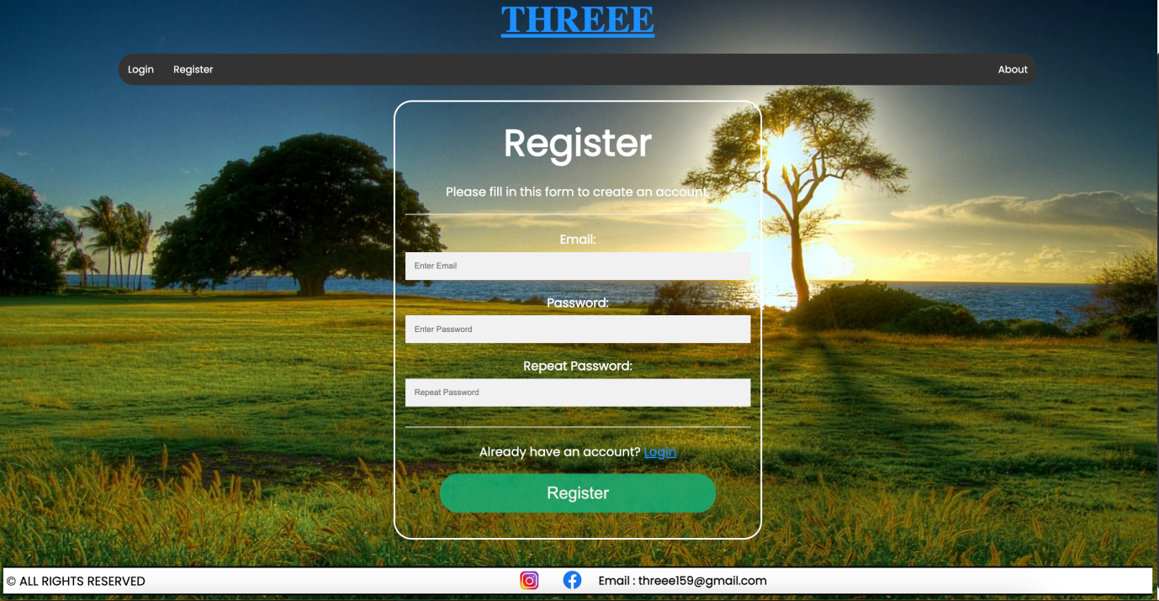

**Figure 5.2 LOGIN**

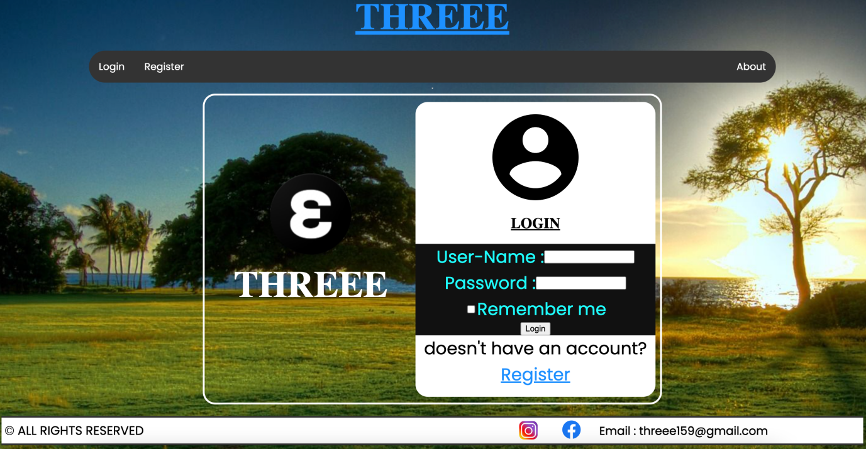

**Figure 5.3 HOME PAGE**

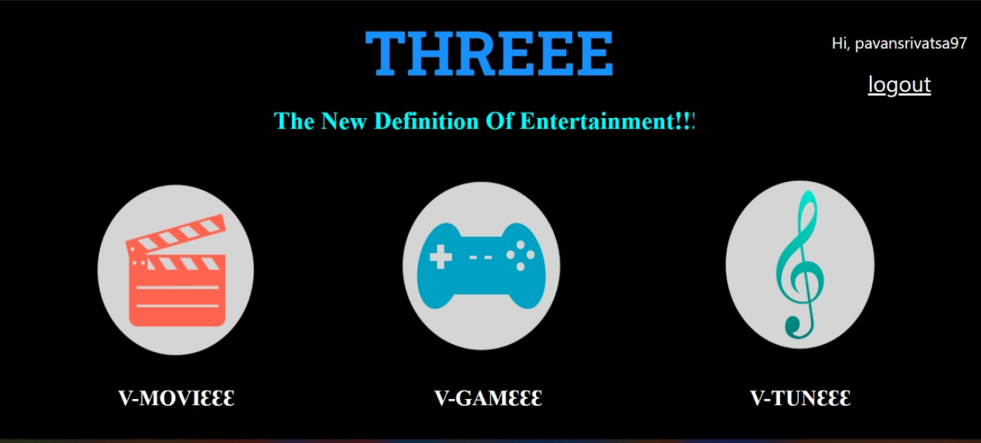

**Figure 5.4 V-MOVIEEE**

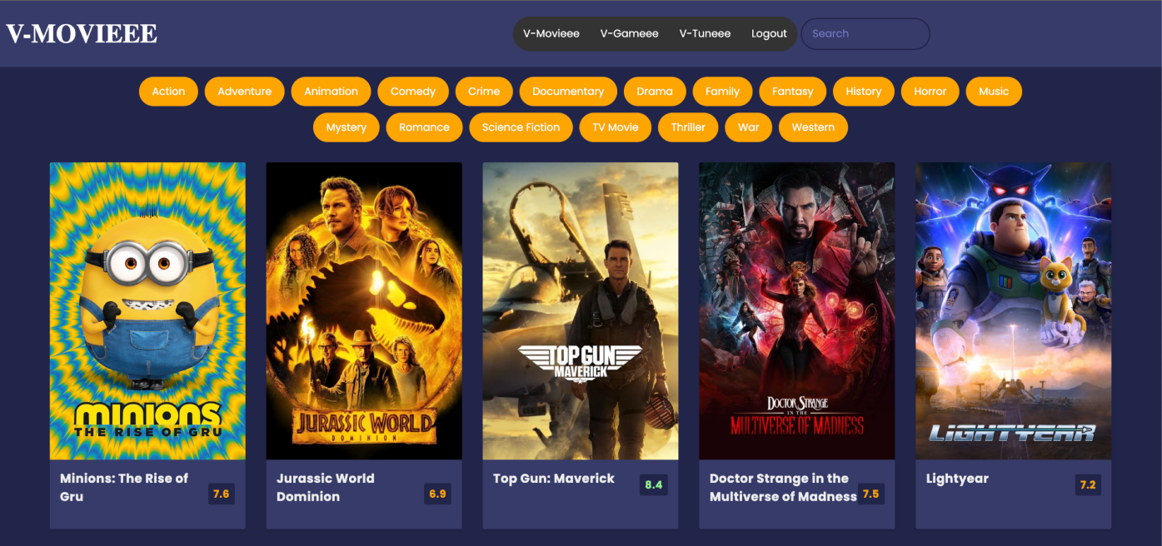

**Figure 5.5 V-GAMEEE**

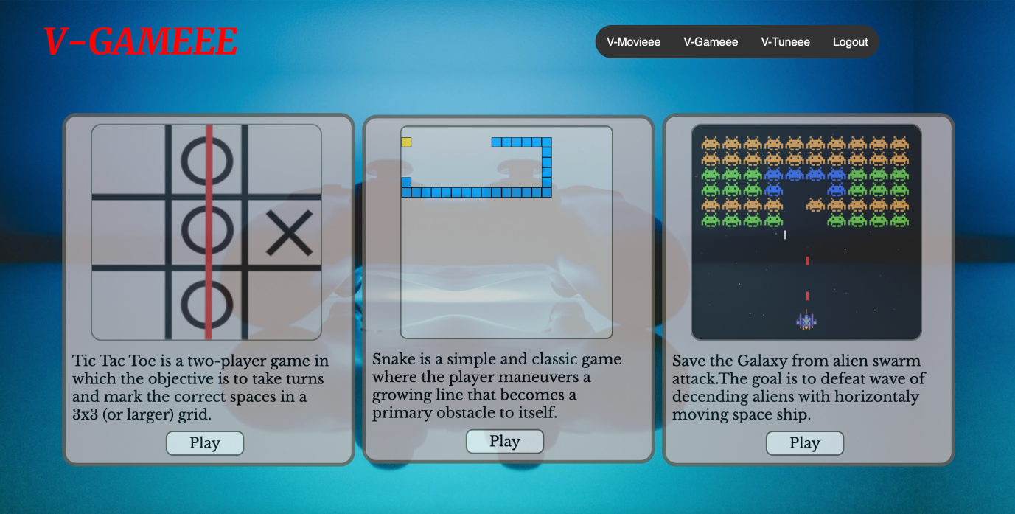

**Figure 5.6 V-TUNEEE**

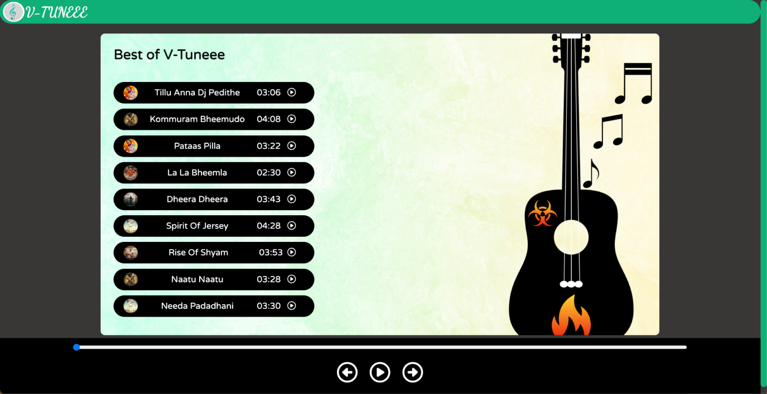

**6. CONCLUSION**

* Hence, we can conclude that the website is:
* User-friendly and Interactive.
* Highly secure.
* Greater Efficiency.
* Better Service.

**7.FUTURE ENHANCEMENTS**

* In future we shall be improving our website by providing subscription which makes the website business-friendly
* This website only contains limited games, in future we will  likely expand it and add few more games.

**8. REFERENCES**

* <https://www.w3schools.com/css/css_navbar.asp>
* <https://freefrontend.com/css-cards/>
* <https://www.wikipedia.org>
* <https://html.com>
* <https://css-tricks.com>
* <https://javascript.info>